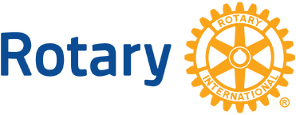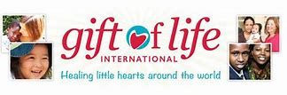

**Rotary District 7680**

**A Gift of Life: Healing Little Hearts Around the World**

Dear Friend in the Community:

The Lake Norman – Huntersville Rotary, North Mecklenburg Rotary, Davidson Rotary and Greater Statesville Rotary clubs are hosting its Fourth Annual Gift of Life Event on **Thursday, March 6 at NorthStone Golf & Country Club** in Huntersville, NC. The evening will begin at 6:00 pm. with a cash bar followed by a sit-down dinner and a program that will focus on the Gift of Life. You will hear from some of the patients in developing countries who have benefitted from funds raised for this wonderful organization.

Our goal is to raise $100,000. In an effort to reach our goal, we will have a Silent Auction.  We would like to know if you would consider making a donation for the auction.  Anything would be appreciated but we suggest a Gift Card/Gift Certificate or a Basket of Items from your business.  Any donation is welcome and appreciated.

If you would like to purchase a ticket to the event, the cost is $100 a ticket.  If you cannot attend, you are welcome to purchase a ticket, where all proceeds will go to the Gift of Life organization. To learn more, go to: [Gift of Life International | Healing Little Hearts Around the World](https://giftoflifeinternational.org/)

Thank you so much for your support of this event, Rotary and our local community!

Sincerely,

David

David Keith

Committee Member – A Gift of Life

Rotary District 7680

***Gift of Life*** *delivers hope to children with heart disease and to their families by empowering doctors and  
nurses with the tools, training, funding and support they need to treat children in their country of birth.  
Gift of Life helps develop stainable pediatric cardiac programs in emerging countries through strategic  
guidance and expanding our global reach through partnerships with like-minded organizations to maximize our impact.*