**The District 7680 PolioPlus Society**

Although the PolioPlus Society was rolled out on September 1st of 2020, many Rotarians are still asking…”PolioPlus Society? What’s that?”

The PolioPlus Society is a group of individuals who are passionate about **Rotary’s #1 Priority**…the elimination of the poliovirus from the face of the earth.

The PolioPlus Society, or PPS, operates much like the Paul Harris Society, whereby a Rotarian or friend makes a commitment to donate $1,000 per year or more to The Rotary Foundation. Except the PolioPlus Society requires you to donate **only** a minimum of $100, and to continue to do so annually until the World Health Organization declares the world free of the poliovirus.

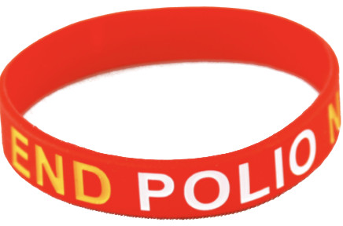PolioPlus Society members will receive a special pin depicting a child receiving the two precious drops, an “End Polio Now” wristband to wear until polio is eliminated from the planet (Both depicted here) and a PolioPlus Certificate proclaiming your membership in this unique Society. Plus the knowledge that you are doing good in the world and are in this fight to the end. Joining the District 7680 Polio Plus Society is a two-step process:

**Step #1 -** Please fill out the below “commitment statement” and email to Polio Chair PDG Tom Smith at [tjsdg7680@gmail.com](mailto:tjsdg7680@gmail.com) or mail to 1840 Tanglebriar CT Matthews NC 28104

I hereby commit to making an annual donation to the PolioPlus Fund of The Rotary Foundation as follows (select one):

* ✓ $100 USD per year (minimum amount to become a society member)
* ✓ A contribution of $_______ per year to PolioPlus (more than $100)

I pledge to help Rotary make history by continuing to contribute the above amount each year until the World Health Organization certifies that polio has been fully eradicated because …***Until the world is polio-free, every child is at risk.***

**Step #2 -** To make your tax-deductible donation go to [myrotary.org/donate](https://my.rotary.org/en/donate) , sign in and click on “Polio Fund”. You can choose a one-time donation of $100 or more, or a recurring donation in the amount and frequency of your choice (We suggest $10/month as the “easy way” to become a PolioPlus Society member.) Of course, you can also write a check payable to “The Rotary Foundation”, with PolioPlus in the memo section, and give to your club’s Foundation Chair.

Name__________________________________________Date_______

Email_________________________________

Club name_____________________________